Starting a Math Talk (before recording student thinking)

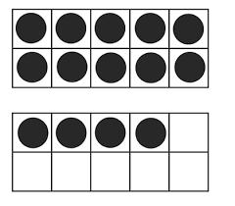
- Display the ten-frame configuration.

- Give think time. Students show thumb signal when they
have a solution.
------------------------------------------------------
15
14 students’ answers
13
- “How many dots do you see?” Call on volunteers, with a
hand raised. Write answers on board.
------------------------------------------------------
15
14
13
4. “How did you figure it out?” Call on volunteers, with a hand raised. Ask student what answer he or she is defending then listen to the entire strategy before recording, pointing to tools, or asking probing questions. If needed, ask questions to encourage the student to continue with their entire explanation. Allow the student to finish before intervening.

Starting a Math Talk (before recording student thinking)

1.Display the ten-frame configuration.

2.Give think time. Students show thumb signal when they
have a solution.
------------------------------------------------------
15
14 students’ answers
13
3.“How many dots do you see?” Call on volunteers, with a
hand raised. Write answers on board.
------------------------------------------------------
15
14
13
4.“How did you figure it out?” Call on volunteers, with a hand raised. Ask student what answer he or she is defending then listen to the entire strategy before recording, pointing to tools, or asking probing questions. If needed, ask questions to encourage the student to continue with their entire explanation. Allow the student to finish before intervening.

